The Researches on Ultimate Capacity of RHS and SHS Stub Columns

Li Ya LI, Chen Hao LIN
School of Civil Engineering, Chang’an University, Xi’an, Shanxi 710061, China
Abstract: This paper develops an analysis of ultimate capacity of hot-rolled RHS and SHS, only considering the effect of local buckling. Finite element models were developed and compared with existed experimental results. A large numbers of computing results obtained by verified numerical models were then applied to systematic parametrical analysis, and compared with different codes and current DSM design curve. It reveals that the ultimate carrying capacity of hot-rolled RHS and SHS stub column is significantly affected by cross-section aspect ratio. Based on current exited direct strength method which is not suitable for hot-rolled RHS and SHS stub column directly, a modified DSM then is proposed in the subsequent analysis. The results show that the modified DSM is able to predict local buckling capacity of hot-rolled RHS and SHS accurately.
Keywords: local buckling, hot-rolled RHS and SHS, direct strength method, cross-section capacity
Email: liya_chd@sina.com

1 Introduction
Cross-section composed by plates needs to consider the overall buckling as well as local buckling behaviors. The ultimate capacity of cross-sections is controlled by yield of steel and local buckling behavior both. EN 1993-1-1 [1] divides cross-sections into four classes based on plate slenderness which considers the ability to resist local buckling, the edge-restraint condition and the stress situation, for plates belong to class 1~3, their cross-sections are overall effective, while for the class 4 sections, effective width method (EWM) is used because of the local buckling phenomenon. However, EWM only considers plate slenderness belongs to the most unfavorable plate, which means it doesn’t consider plate interaction. Studies of Zhou Fen [2] show that the interaction between flange and web affects the ultimate carrying capacity of RHS/SHS a lot. Direct strength method (DSM) proposed by Shafer [3] which is alternative to EWM has been widely used in cold-formed thin-walled steel and involved in North American Specification for Design of Cold-Formed Steel. Li [4] extended the DSM into the field of hot-rolled I cross-section. But whether DSM is suitable for square and rectangular hollow sections (RHS/SHS) in compression needs further studies.

2 Numerical Investigation
2.1. Finite Element Model
Finite element models of hot-rolled RHS/SHS stub columns were developed by using the non-linear finite element program ABAQUS [5], in which two steps including linear perturbation and non-linear analyses were performed in order to obtain the ultimate carrying capacity and failure modes of RHS/SHS stub columns. Material properties and cross-section dimensions measured from Joanna’s test [6] were included in the finite element model. The typical nomenclature is defined in Figure 1.
H
h
t
r
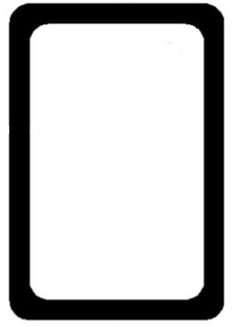
B
b

Figure 1 Cross-section Dimension of RHS/SHS

S4R element (a four-node doubly curved shell element with reduced integration) was used for all models inasmuch as it is able to solve complex buckling behavior. As for the mesh sizes, every flange was divided into 20 parts, every web was divided into 20 parts and every corner was divided into 4 parts along the arc length but all mesh sizes should not bigger than 10×10mm, which could facilitate the results converge to the global minimum. The typical finite element mesh generation is presented in Figure 2. Because warping effect is not influential for RHS/SHS, load transfer plate was not used in the models. The axial compressive force and boundary conditions were applied in two reference points which were in the top and bottom of each model respectively. The “tie constraint” ties finite element model and each reference point together, which ensure the translational and rotational degrees of freedom identical to the reference points. The reference points were restrained against all degrees of freedom, but not for the displacement at the top reference point in the direction of the applied load.
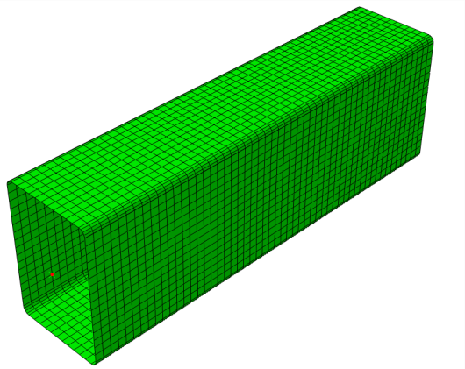
Figure 2 Finite Element Mesh Generation

In that overall buckling behavior can be ignored in stub columns, local geometric imperfection was added into the models by using the lowest buckling mode shape obtained in the first step of analysis as mentioned before. The local imperfection amplitude, h/200 and the material model suggested by Joanna [6] were used in the finite element analysis.

2.2 Verification of the Finite Element Model
Eight experimental specimens were used to verify the finite element model. Comparisons between the numerical and experimental results are presented in table1, in which P_{u, test} and P_{u, FEM} are the ultimate carrying capacity of tests and finite element models respectively. The average value of P_{u, FEM} /P_{u, test} is 1.01 and the variance of that is 3.91%, which reveals that finite element models agree with test results very well. Therefore, the finite element model established in this paper is able to predict the ultimate carrying capacity of stub columns accurately.

Table 1 Comparison Between Numerical and Experimental Results
Specimen | P_{u, test}  (kN) | P_{u, FEM}  (kN)
R 250-150-5 A | 1478 | 1493 | 1.01
R 250-150-5 B | 1358 | 1416 | 1.04
R 200-100-5 A | 1159 | 1211 | 1.04
R 200-100-5 B | 1163 | 1189 | 1.02
S 200-200-5 A | 1604 | 1566 | 0.98
S 200-200-5 B | 1607 | 1667 | 1.04
S 200-200-6.3 A | 2168 | 2253 | 1.04
S 200-200-6.3 B | 2227 | 2086 | 0.93
Mean |  |  | 1.01
Cov |  |  | 3.91%

2.3 Parametric Studies
With the finite element models validated, further numerical analyses were done to generate results over a wider range of geometries and local slenderness to evaluate whether DSM is suitable for hot-rolled RHS/SHS stub columns. A total of 864 different RHS/SHS were modeled, which cover three kinds of yield strengths (S275, S355, S460) and four kinds of cross-sections defined in EN 1993-1-1 [1]. The value of aspect ratio (h/b) varies from 1mm to 3mm, the value of B varies from 40mm to 80mm, the value of H varies from 40mm to 200mm and the value of inner radius which equals to the value of thickness varies from 1.5mm to 5mm. The material properties used in the parametric studies are presented in table 2 and other properties that are not mentioned in this paper can refer to EN 1993-1-1 [1] and ECCS [7].

Table 2 Material Properties of Steels
Steel Grades | E  (Mpa) | f_{y}  (Mpa) | f_{u}  (Mpa) | ε_{y}  (%) | ε_{u}  (%)
S275 | 210000 | 275 | 430 | 1.3 | 21.6
S355 | 210000 | 355 | 490 | 1.7 | 16.5
S460 | 210000 | 460 | 560 | 2.2 | 10.7

3 Comparisons between the Results of FEM and Different Codes
The results from three codes including EN 1993-1-5 [8], AISC 360 [9] and GB50017 [10] are shown in figure 3~5, in which h/tε represents the cross-section slenderness and the ε is defined in EN 1993-1-5 as [8]. The result shows that the tendency of RHS and SHS are different. Therefore, the interaction between plates should not be ignored since it influences the ultimate carrying capacity of RHS/SHS a lot. Furthermore, the formulae of EN 1993-1 and AISC 360 are unsafe when cross-section slenderness is larger than 20 around, especially for SHS, while the formula of GB50017 is conservative for almost all cross-section slenderness.

Figure 3 Comparison between the Results of Finite Element Models and EN 1993-1

Figure 4 Comparison between the Results of Finite Element Models and AISC 360

Figure 5 Comparison between the Results of Finite Element Models and GB50017

4 Modified DSM
For the stub columns , the formulae of DSM are detailed as follows [4], in which the P_{y} is the yield load, the λ also represents the cross-section slenderness and theis calculated through finite strip method software CUFSM. Comparison between the results of finite element models and DSM are shown in Figure 6. It is clear that the current DSM is not able to be applied in hot-rolled RHS/SHS, so it needs modification.
(1)
(2)

Figure 6 Comparison between the Results of Finite Element Models and DSM

For the different tendencies of SHS and RHS appeared, the modified DSM is divided into two parts and further details are shown in Figure 7, from which it is clear that the modified DSM agrees well with the finite element ones.
for SHS,
(3)

for RHS,
(4)

Figure 7 Comparison between the Results of Finite Element Models and Modified DSM

5 Conclusion
This paper presents and discusses the ultimate carrying capacity and local buckling behavior of hot-rolled RHS and SHS stub column. The result shows that the interaction between plates should be considered into formula. The comparison of different codes reveals that EN 1993-1, AISC 360 and GB50017 are conservative or unsafe. Based on the current DSM, a modified DSM formulation then is proposed, which agrees well with the finite element models compared with formulae of codes.

References

[1] Eurocode 3: Design of Steel Structures: Part 1-1: General Rules and Rules for Buildings[S]. European Committee for Standardization, 2005.
[2] Zhou F, Chen Y, Young B. Cold-formed high strength stainless steel cross-sections in compression considering interaction effects of constituent plate elements[J]. Journal of Constructional Steel Research, 2013, 80: 32-41
[3] Schafer B W. Review: the direct strength method of cold-formed steel member design[J]. Journal of constructional steel research, 2008, 64(7): 766-778.
[4] Li Y. Extension of the Direct Strength Method to hot-rolled and welded H profile cross-sections[D]. Université de Liège, Liège, Belgique, 2014.
[5] Hibbett, Karlsson, Sorensen. ABAQUS/standard: User's Manual[M]. Hibbitt, Karlsson & Sorensen, 1998.
[6] Joanna Nseir. Development of A New Design Method for the Cross-Section Capacity of Steel Hollow Sections[D] . Université de Liège, Liège, Belgique, 2015.
[7] ECCS, Ultimate Limit State Calculation of Sway Frames with Rigid Joints [J] . ECCS publications, 1984.
[8] Eurocode 3: Design of Steel Structures: Part 1-5: Plated Structural Elements[S]. European Committee for Standardization, 2006.
[9] ANSI B. AISC 360-10-Specification for Structural Steel Buildings[J]. Chicago AISC, 2010.
[10] GB. 50010-2003, Code for design of steel structures[S]. Beijing: China Architecture & Building Press, 2003.

